12 cities: Where to buy and where to rent

Last updated October 11 2010: 11:53 AM ET

Cities like Detroit and Columbus boast killer buying opportunities, but you're better off renting in places like New York and Seattle, according to Trulia's quarterly Rent vs. Buy index.
Detroit: Buy

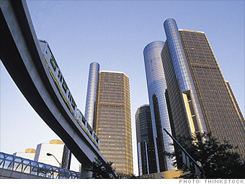
Average list price: $142,154
Average monthly rent : $1,055
Price to rent ratio: 11.22

While home prices have shot up 20% in the last year and manufacturing and auto jobs are beginning to rebound, it's still a better bargain to buy in Detroit.
"While prices have risen in the past year, prices overall are still on the low end and buyers have the opportunity to get into the market at a reasonable price," said Ken Shuman, a spokesman for Trulia.

